SETr Workflow Guide
Is marsh surface tracking sea level change?
Developing tools and visualizations for NERRS Sentinel Site Data

In this guide:
- Background on the SETr project and goals ……………………………………………… 3
- Workflow instructions ………………………………………..………………………………….. 5
- Details on data & metadata files and QA/QC codes ………………………………… 6
- Where to find important files in the directory ………………………………………… 7
- Contents of the entire directory on your computer ..……………………………… 9

This work is sponsored by the National Estuarine Research Reserve System Science Collaborative, which supports collaborative research that addresses coastal management problems important to the reserves. The Science Collaborative is funded by the National Oceanic and Atmospheric Administration and managed by the University of Michigan Water Center (NAI4NOS4190145).

Project Partners:
This page intentionally left blank
1. Background on SETr project and goals

project abstract here

meant to be not just analyses on past data, but a workflow that can be used in the future for data entry, QA/QC, and repeating these analyses on the growing datasets

this is a stepping-stone on the way to system-wide SET data management; it does not replace the need for a standardized, system-wide database; but should help bridge the gap. We have transformed data sets from 15 Reserves into the standardized format you will see on the following pages. We have put a lot of thought into not only the code to run the analyses, but also the user interface; our intent is for this workflow to be understandable and easily repeated, even for people who are uncomfortable with R software.

instructions everywhere: this guide is meant to be a thorough introduction to finding your way around the file directory and workflow. each R script that is meant to be run the end-users also has instructions at the beginning of it on the specifics of running it. In output documents, particularly the outreach doc, there are explanations of the graphics and analyses. The technical output document also contains file paths for all saved graphics. This makes the output a graphical table-of-contents of sorts. Saved versions of graphics tend to look different than those automatically inserted into Word, so the saved versions may be better in presentations and elsewhere.

Major outputs are produced in Microsoft Word, .docx format. This allowed the SETr team to provide basic framework and wording through the R code, but the documents are easily modified if end-users want to add additional, site-specific information, or remove any redundant graphics or tables.
- The first of these is a report with analyses of rate of change over time at each SET in a reserve. The document includes graphics to show change over time, graphical comparisons to sea level rise, a spatial view of the changes within a reserve, and tables of all the relevant numbers and levels of uncertainty. This document is aimed at technical reserve staff that already understand SETs and their importance.
- The second Word document is an outreach report, aimed at reserve outreach staff. This document contains more detail on what SETs are, and steps through graphs a bit more slowly to build up the concepts within each one and help them be understandable to broader audiences. While the SETr team attempted to provide background and context in this document, it probably still needs to be supplemented by other information based on the goals of the specific outreach person using it. We encourage reserve outreach staff to talk to reserve technical staff about the specific information contained in this document, and how to interpret it.

2. Workflow Instructions

Example file names use the reserve code GND; in reality the files will use your 3-letter reserve code. Instructions on running scripts are included at the top of each.

I. Set up the project
Necessary once per computer, or if your R/RStudio installations are not current
- Make sure a current version of R software (3.5.3 or higher) is installed.
- If you do not have R, you can download it for your operating system at https://cran.r-project.org/
- Make sure a current version of RStudio (1.2 or higher) is installed.
- Use the free, Open Source License version of RStudio Desktop at this link: https://rstudio.com/products/rstudio/download/
- unzip the folder you were provided with; details on everything in the directory are in chapter 4 of this document.
- In the top level is a file called Reserve_Template.Rproj. Open this; it will open a session of RStudio.
- In the lower right pane of RStudio, click on the “Files” tab. Navigate to the “R_scripts” folder.
- Click on the file 00a_install_packages.R. This will open in the top left pane of RStudio. Follow the instructions at the top to run the script; this will install all necessary R packages for this workflow.
- Next, click on the file 00b_check_packages.R. Follow the instructions at the top of the script to run it. When the output in the console (bottom left pane) says “All required packages are installed and loading properly!”, you’re ready-to-to.

II. Enter new SET data
Yearly (or the same frequency at which you take measurements)
- Enter data into the raw data spreadsheet: data/raw/GNDset.xlsx
- A detailed breakdown of this spreadsheet is in section 3 of this document.

III. Run a processing script
EVERY TIME you update the raw data
- Open the RStudio Project file: Reserve_Template.Rproj
- Open and run: R_scripts/01_process_raw_data.R
  - script purpose:
    - pull in your raw data and reformat it into a computer-friendly version
    - the file produced by this script will be used in all further analyses
  - files used by script:
    - data/raw/GNDset.xlsx
    - R_scripts/sourced/000_functions.R
  - files produced by script:
    - data/processed/GNDset_processed.csv

IV. Run interactive QA/QC app
Identify potential errors in data recording/entry and recognize influential events that could impact data; so corrections can be made and documentation added as necessary
- Open the RStudio Project file: Reserve_Template.Rproj
- Open and run: R_scripts/02_interact_qaqc_app.R
  - script purpose:
    - allow you to interact with data in various ways:
      - Pin Readings tab
      - Incremental Changes tab
      - Cumulative Change tab
  - files used by script:
    - data/processed/GNDset_processed.csv
    - R_scripts/sourced/000_functions.R
  - files produced by script:
    - none

V. Fix/flag any problems
Make any changes in the raw data spreadsheet
- data/raw/GNDset.xlsx
- Refer to metadata/user_defined_inputs.xlsx, qaqc_codes tab to add QA/QC codes to your data file

VI. Update metadata
Optional
- metadata/GNDset_metadata.xlsx
- A detailed breakdown of the metadata template is in section 3 of this document
- Ideally, in the future there will also be a narrative form of metadata that can include longer comments and explanations

VII. Re-run processing script
Required if you have modified your raw data file
- Open the RStudio Project file: Reserve_Template.Rproj
- Open and run: R_scripts/01_process_raw_data.R
  - script purpose:
    - pull in your updated raw data and reformat it into a computer-friendly version
    - the file produced by this script will be used in all further analyses
  - files used by script:
    - data/raw/GNDset.xlsx (updated in step 5)
    - R_scripts/sourced/000_functions.R
  - files produced by script:
    - data/processed/GNDset_processed.csv (updated version; will overwrite previous version)

VIII. Specify output options
- metadata/user_defined_inputs.xlsx
- This file includes aesthetic options for graphs (see section 3), such as how many columns you want in multi-panel graphs; dimensions you’d like for the graphs; and which QA/QC codes (see section 3 of this document) you want to use to indicate data that should be ignored in this analyses.

IX. Run analysis scripts
- Open the RStudio Project file: Reserve_Template.Rproj
- Open and run: R_scripts/03_analyze_word.R
  - script purpose:
    - generate two reports for your reserve, one for technical audiences and one for NERR outreach staff to translate to their audiences. Each will have versions of:
      - SET elevation change rates at your reserve
      - comparisons to 0 and to sea level rise
      - tables, graphs, and maps illustrating these results
    - generate a summary file of rates, comparisons, and SET locations that can be used later in the interactive mapping script
  - files used by script:
    - data/processed/GNDset_processed.csv
    - metadata/GNDset_metadata.csv
    - metadata/slr_rates.csv
    - metadata/user_defined_inputs.xlsx
    - R_scripts/sourced/000_functions.R
    - R_scripts/sourced/005_rate_calculations.Rmd
    - R_scripts/sourced/0055_outreach_graphics.Rmd
    - R_scripts/sourced/006_map_making_static.Rmd
    - img/[all files in directory].png
  - files produced by script:
    - data/intermediate/rate_summary.csv
    - R_output/analysis/SET_Analyses_yyyy-mm-dd.docx
    - R_output/outreach_doc/SET_Outreach_yyyy-mm-dd.docx
    - R_output/figures/cumu_change_plots/[folder with change-over-time graphs]
    - R_output/figures/maps/[folder with maps]
    - R_output/figures/summary_plots/[folder with dot-and-whisker plots]
- Open and run: R_scripts/04_interact_maps.R
  - script purpose:
    - Make maps that you can interact with to see your results spatially
  - files used by script:
    - data/intermediate/rate_summary.csv
    - R_scripts/sourced/007_map_making.R
    - img/[all files in directory].png
  - files produced by script:
    - none unless you save things interactively from RStudio’s Viewer pane

X. Submit processed data and metadata to the CDMO
Not yet possible, but recommended annually for flat file hosting (optional)
- data/processed/GNDset_processed.csv
- metadata/GNDset_metadata.xlsx
- narrative metadata, if developed

3. Details on data & metadata files and QA/QC codes

data/raw folder
Guidelines for use of the raw file:
- DO NOT CHANGE column names
- you can change colors and column widths
- If you enter clock times, make sure the column is text – Excel does weird conversions of times that aren’t associated with dates

How the Excel “raw” files are organized (see Fig. ____ below):
- one worksheet per SET
- one row per arm per date = 4 rows per date
- columns: set_id, date, arm_position, arm_qaqc_code, pin height and qaqc_code columns (see below), any additional things you've recorded (reserve; reader; weather)
- 18 pin columns: each of the 9 pins gets 2 columns: one for height (mm or cm; incorporated in column name) and one for a qaqc code
- pin qaqc_code columns are to the right of the pin measurement columns, because in theory they'll be used less often; so they're out of the way
- all other columns in the original reserve file have been preserved in this file and are to the far right

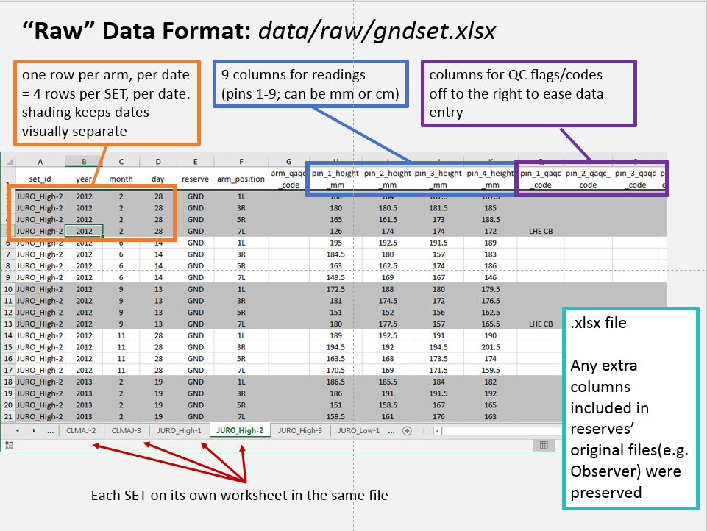
Fig. ____: Annotated example of raw data file

data/processed folder
DO NOT MODIFY THIS FILE
This is only an explanation of what it contains
- columns are: (see figure ___ below)
  - set_id
  - year, month, day – for measurement date; kept as separate columns for formatting
  - arm_position
  - arm_qa_qc_code
  - pin_number
  - height_mm or height_cm
  - qaqc_code – pin-level documentation
  - reserve
  - any other columns included in original data file
- generated by script R_scripts/01_process_raw_data.R; used by all subsequent scripts and analyses

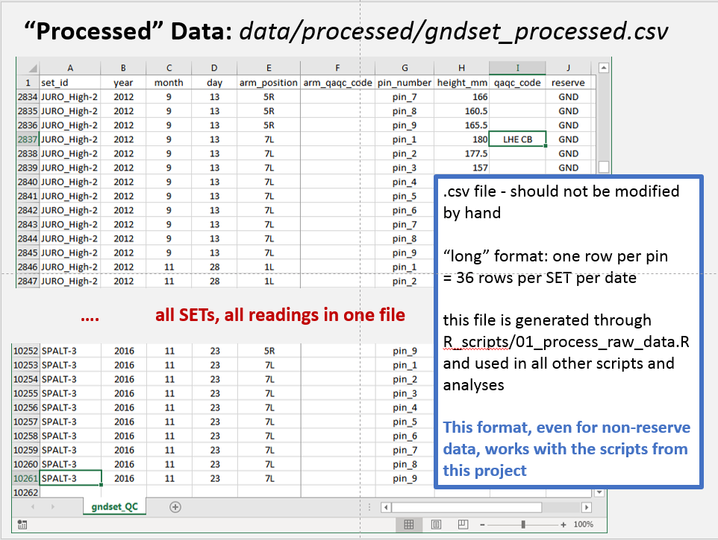
Fig. ____: Annotated example of processed data file

metadata folder
Main metadata file, gndset_metadata.xlsx:

This file was built off of a template under development by the NERRS SET working group. Most columns are in the same order even if they were not used in this project. The following columns are those that have been used in SETr code, along with a parenthetical notation about whether it was in the original SET working group template (existing), modified from that template (modified), or completely new (created) for this project.
- Unique SET ID (existing)
- User-friendly SET name (created)
- Numerical Order
- Reserve
- CoDominant Species1 (modified): originally “Dominant Vegetation”; end-users on SETr requested multiple columns as some sites have co-dominant vegetation.
- CoDominant Species2, 3, 4 (created): to address the above.
- Latitude (Dec. Deg.) (existing)
- Longitude (Dec. Deg.) (existing): use negative numbers for “west” longitude
- Set Type (existing): Generally deep rod, shallow, or original
- Surface Elevation Ground (NAVD88) (existing)
- Surface Elevation Receiver (NAVD88) (existing)
- Notes (created)

Information on Sea Level Rise rates, slr_rates.csv:

This file originated as a google doc in which we compiled “local” sea level rise information for participating reserves. Each reserve was asked to provide information from the nearest NWLON station, including the NOAA COOPS-generated calculation and 95% confidence interval for sea level rise. Some of these NWLON stations are more than 30 km away from the reserves, which is why “local” is in quotes. Information pulled from an NWLON’s station webpage is highlighted in figure ____ below. Columns in this file are:
- Reserve – three-letter reserve code
- Nearest NWLON Station – station name of NWLON gauge closest to the reserve and its sites
- Distance to NWLON Station – approximate, as provided by reserves
- NWLON Station Number – the identifying number for the NWLON gauge
- SLR rate (mm/yr) – sea level rise rate provided on the graph for the NWLON station’s sltrends page
- +/- (95% CI) – confidence interval half-width provided by NOAA COOPS for the rate of sea level change at this NWLON station (e.g., SLR rate +/- this number gives the full 95% confidence interval for the SLR estimate)
- data start – year that the time series used in calculating sea level rise starts at this station; provided from the NWLON station site
- data end – year that the time series used in calculating sea level rise ends at this station; provided from the NWLON station site
- set start – year that SET data collection started at a reserve in the file submitted for SETr
- slr_19-yr – 19-year water level change, calculated as part of the SETr project, using the same deseasonalized monthly average sea level data and same method (ARIMA 1,0,0) used in the long-term sea level rate calculations. Before adding this number to the spreadsheet, we verified that long-term rates and confidence intervals generated through SETr project calculations matched those on the COOPs site.
- ci95_19yr – confidence interval half-width generated by SETr code for 19-year sea level change rate (e.g., slr_19yr +/- this number gives the full 95% confidence interval for the 19-year sea level change rate estimate)
- yr19_start – the start of the period for 19-yr calculations; based on the given end-date for the long-term SLR estimate, minus 19 years.
- yr19_end – the same end date as provided by the reserve for long-term SLR rate
- link – link to NWLON station page, provided by reserve

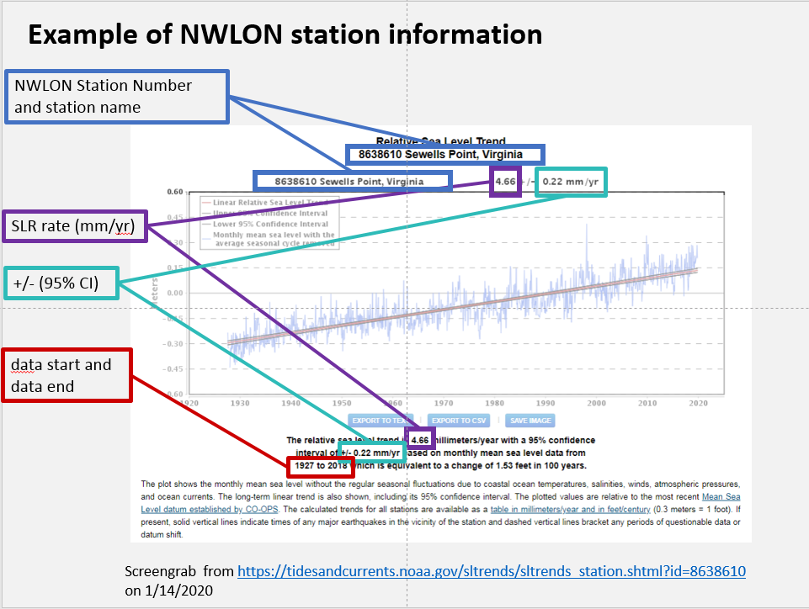
Fig. ___: Example of NWLON station website and information from it that was provided by reserves in the slr_rates.csv spreadsheet. Most pieces of information can be found in multiple places on this page.

user_defined_inputs file:
- qaqc_codes tab
  - includes the list of codes in Table 1
  - to exclude data points associated with certain codes (full codes and combinations in column J) from analysis, type -3 (no quotes) into column A
- general tab
  - The only changes you should make in this sheet are in the Value column. DO NOT CHANGE anything in the R_param colum. DO NOT CHANGE column names.
  - Which graphs are controlled by which dimensions?
    - “tall, skinny graphs” – rows 5 and 6:
      - cumulative change graph with NAVD88 y-axis:
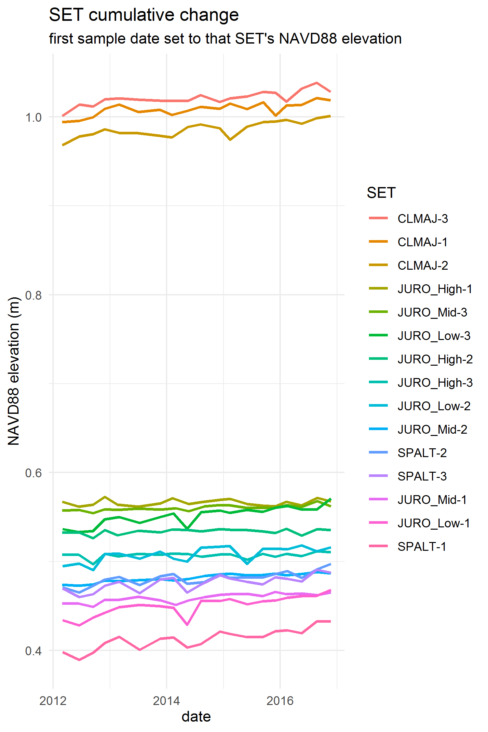
    - “wider than tall graphs” – rows 7 and 8
      - cumulative change graphs for individual SETs
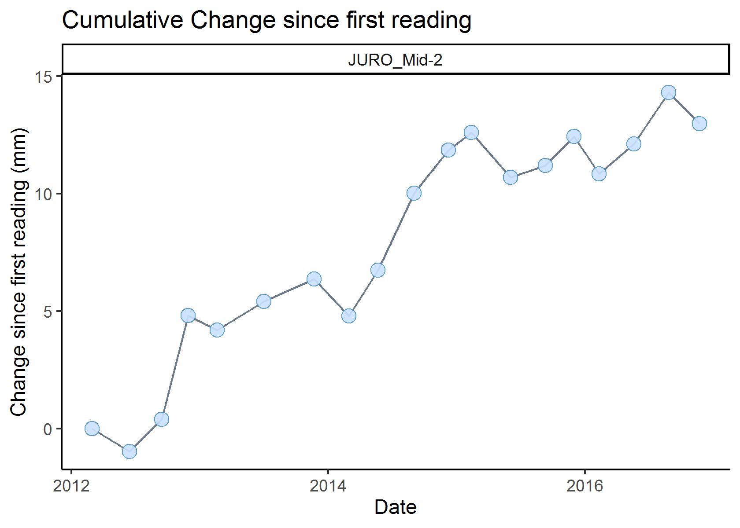
      - summary plots
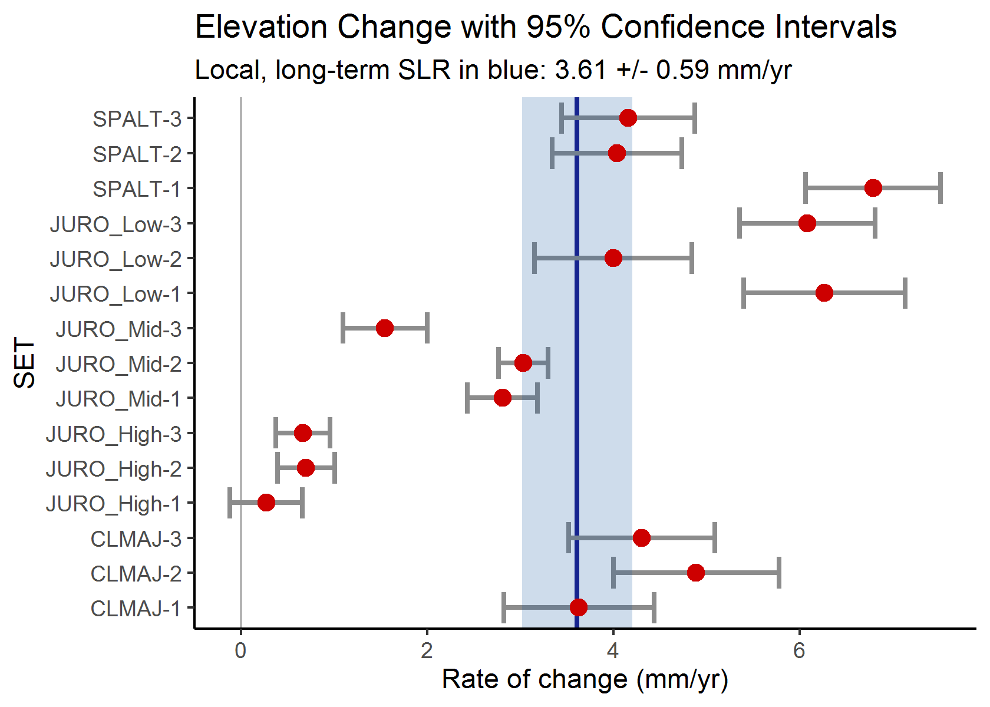
    - “square graphs” – rows 9 and 10
      - cumulative change graphs with multiple panels (one panel per SET)
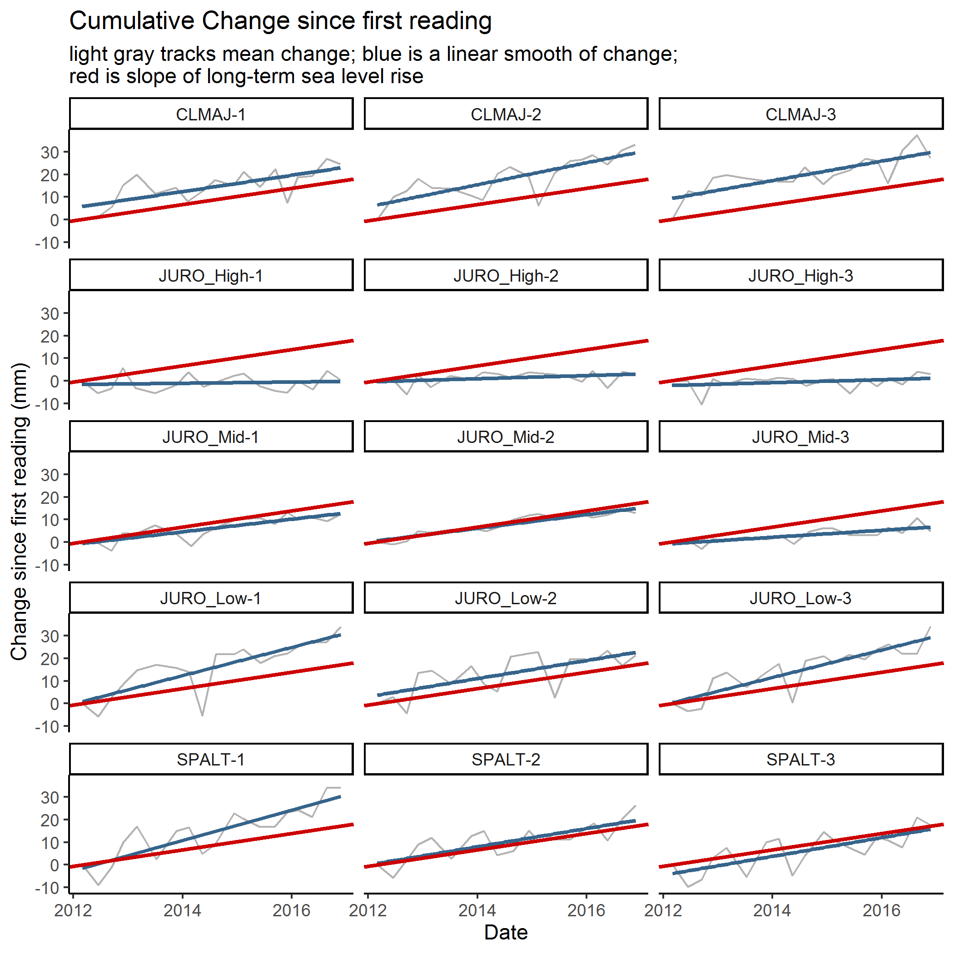

QA/QC codes:
These QA/QC codes were iteratively developed over the course of the SETr project. We see them as a starting point as the NERR system moves forward with standardized data management practices. Through many discussions of things that can go wrong during measurement of SET pins, we first developed a list of common problems. Then we developed 3-letter codes, to be consistent with current QA/QC coding for SWMP water quality/weather/nutrient data. These were broken into three main categories: a pin landed higher than expected (codes start with H), lower than expected (codes start with L), or a general comment (codes start with C). After more discussion of specific situations encompassed by each 3-letter code, we also developed suggested secondary codes to concisely capture more detail about common problems. These do not follow a naming pattern like the primary 3-letter codes do, and should only be used along with a primary, 3-letter code. We did not develop SWMP-like numeric flags as we felt judgements of what should in general be marked suspect or rejected should be reserved for future practitioners. For now, decisions about what to exclude from analysis are left up to reserves, and can be specified in the spreadsheet metadata/user_defined_inputs.xlsx, on the qaqc_codes tab by typing “-3” (no quotes), this is the general SWMP flag for rejected data, in column A.

Use of QA/QC codes in the raw data file:
- arm_qaqc_code column exists in case there's some landscape-level issue affecting an entire arm.
- pin_#_qaqc_code columns are off to the right. there is one for each pin.
- use 3 and 2 letter codes from the qaqc_codes worksheet in those columns.
- you can put multiple codes in a column; separate them by a space
- don't use a 2-letter code without the corresponding 3-letter code
- codes are roughly divided into: C-- (general comments); H-- (pin landed higher than "expected"); L-- (pin landed lower than "expected")

Table 1. Suggested QA/QC codes for use with SET data.
SET QA/QC Codes
QAQC Codes | 1º code |  |  |  | 2º code; use only with accompanying primary code
Higher than "expected" | HMD |  | High - Mound
Higher than "expected" |  |  |  | CH |  | Chimneys (e.g. crab chimneys or worm mound/casts)
Higher than "expected" |  |  |  | AL |  | Algae
Higher than "expected" | HPD | High - Plant, Dead
Higher than "expected" |  |  |  | ST |  | Stems
Higher than "expected" |  |  |  | RT |  | Roots
Higher than "expected" |  |  |  | WR |  | Wrack
Higher than "expected" |  |  |  | AL |  | Algae
Higher than "expected" |  |  |  | VV |  | Vascular vegetation
Higher than "expected" |  |  |  | VH |  | Vegetation Hummock
Higher than "expected" | HPL | High - Plant, Live
Higher than "expected" |  |  |  | ST |  | Stems
Higher than "expected" |  |  |  | RT |  | Roots
Higher than "expected" |  |  |  | AL |  | Algae
Higher than "expected" |  |  |  | VV |  | Vascular vegetation
Higher than "expected" |  |  |  | VH |  | Vegetation Hummock
Higher than "expected" | HSM | High - Solid Matter
Higher than "expected" |  |  |  | LS |  | Live Shellfish
Higher than "expected" |  |  |  | SH |  | Shell (dead shellfish)
Higher than "expected" |  |  |  | RK |  | Rock(s)
Higher than "expected" |  |  |  | SK |  | Stick(s)
Higher than "expected" | HDI | High - deposition derived from ice rafting
Lower than "expected" | LDP | Low - depression
Lower than "expected" |  |  |  | AP |  | Animal Prints (ephemeral)
Lower than "expected" |  |  |  | HP |  | Human Prints (footprints)
Lower than "expected" |  |  |  | TR |  | Trough, Shallow
Lower than "expected" |  |  |  | MB |  | Mammal Burrow (e.g. muskrats)
Lower than "expected" |  |  |  | WR |  | Wrack, removed
Lower than "expected" |  |  |  | SR |  | Shell, removed
Lower than "expected" | LHE | Low - hole
Lower than "expected" |  |  |  | CB |  | Crab Burrow
Lower than "expected" | LSC | Low - Scour/trough
Lower than "expected" | LSM | Low - soft mud
Lower than "expected" | LPS | Low - pin slipped/dropped (not lowered slowly, may be "too far down")
General Comments | CRM | Comment - reading missing
General Comments |  |  |  | PM |  | Pin missing/ broken
General Comments |  |  |  | SI |  | Sudden inundation
General Comments | CUW | Comment - pin under water
General Comments |  |  |  | SW |  | Standing Water
General Comments |  |  |  | SI |  | Sudden Inundation
General Comments |  |  |  | IT |  | Incoming Tide
General Comments |  |  |  | PA |  | Paper used for resistance
General Comments | CUS | Comment - Uncertain Surface (e.g. post-hurricane debris, wrack, pine needles, algae mats)
General Comments | COS | Change in Observer - short term (< 1 seasons' worth)
General Comments | COL | Change in Observer - long term
General Comments | CEP | Change in Equipment/Protocol
General Comments |  |  |  | AH |  | new arm hardware
General Comments |  |  |  | AP |  | new arm position
General Comments |  |  |  | NP |  | new pins
General Comments |  |  |  | SM |  | SET modification, e.g. raised receiver due to sedimentation
General Comments | CCF | Comment - Correction Factor Needed
General Comments |  |  |  | MT |  | Measurement technique has changed
General Comments |  |  |  | NP |  | New pins; when combined with CCF, different length than previous
General Comments |  |  |  | SM |  | SET modification, e.g. raised receiver due to sedimentation
General Comments | CSI | Comment - Structural Instability
General Comments |  |  |  | RU |  | Rod not stable
General Comments |  |  |  | WE |  | Wind affecting arms during measurements
General Comments | CLY | Comment - Measured less than a year post-installation
General Comments | CHL | Comment - Hummocky Landscape (whole arm)
General Comments | COT | Comment - Other

4. Where to find important files

Enter your latest measurements
data/raw/GNDset.xlsx (substituting your Reserve code for ‘GND’)

Update your metadata
metadata/GNDset_metadata.xlsx

Update Sea Level Rise information
metadata/slr_rates.csv

Find the list of QA/QC codes
metadata/user_defined_inputs.xlsx, qaqc_codes tab

Specify which QA/QC codes you want to exclude from analyses
metadata/user_defined_inputs.xlsx, qaqc_codes tab

Specify other options for your graphs and analyses
metadata/user_defined_inputs.xlsx, general tab

Find the technical analysis
R_output/analysis/SET_Analyses_yyyy-mm-dd.docx

Find the outreach document
R_output/outreach_doc/SET_Outreach_yyyy-mm-dd.docx

5. Contents of the Directory
details on each folder and subfolder, sorted alphabetically

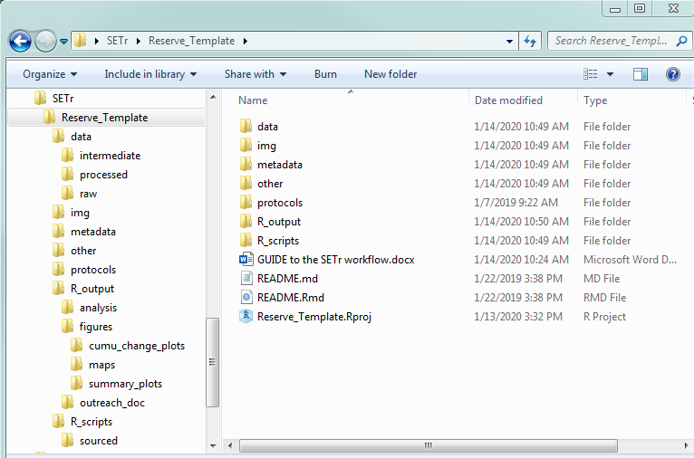
Fig. ____: Overview of the entire directory. On left, the directory “tree”, showing the folders within each folder. On right, the main directory is open, showing all files and folders in the “top level”.

- data
  - intermediate: do not modify this folder on your own. It contains automatically generated files from the analysis. Currently the only file is:
    - rate_summary.csv - a table that contains a single row for each SET, and columns including the rate of change in mm/yr and the 95% CI bounds
  - processed: do not modify this folder on your own. It contains an automatically generated file containing your SET data in a long format: one row per pin. The file contains all SETs, all dates, and all parameters you included in your raw file. This file is generated by the R script ‘01_process_data.R’ and is used in all subsequent scripts. The name format of the file is, with your reserve abbreviation in place of ‘GND’:
    - GNDset_processed.csv
  - raw: DO modify this file. This is the raw data file. It is an Excel file, with one worksheet per SET. Within a worksheet, there is one row per arm position per date, with separate columns for each pin measurement on that arm, columns for qa/qc codes, and columns for anything else your reserve has been recording. The name format is:
    - GNDset.xlsx

- img do not modify this folder on your own. These files must be present for the scripts to work properly.
  - arrows.pptx – has all of the map icons that generated the pngs below, along with their hex and RGB colors. This is the only file that can be modified or removed without a problem.
  - blue_up_arrow.png
  - gray_down_arrow.png
  - gray_up_arrow.png
  - red_down_arrow.png
  - SET_diagr2_NPSprotocols.png
  - SET_measurement_creditHudsonRiverNERR.jpg
  - yel_not_enough_info.png

- metadata
  - GNDset_metadata.xlsx DO modify this file as needed. Do NOT change existing column names, but feel free to add new columns.
  - slr_rates.csv DO modify this file as needed. Do NOT change existing column names, and make sure there is only a single row for your reserve. This spreadsheet is where the scripts find your local rate of sea level rise for comparisons to SET elevation changes.
  - user_defined_inputs.xlsx DO modify this file! There are options for customizing your graphs and plots, as well as excluding data associated with certain QA/QC codes.

- other DO modify this folder. There is nothing related to these R scripts; it is simply for you to include any other relevant files you want in the same directory.

- protocols DO modify this folder. This is where you can include your Sentinel Site Plan and other reserve-level documentation.

- R_output do not modify this folder on your own unless it’s to change the name of an output file. Anything in here is automatically generated from the scripts.
  - analysis This is where the technical Word report is saved.
  - figures This is where plots and graphs will be saved.
  - outreach_doc This is where the outreach-oriented Word report is saved.

- R_scripts don’t mess with these unless you really know what you’re doing

Appendix 1: FAQs/Troubleshooting tips

I see something in the report that says “warning” – what does it mean?
(depends)
- “warning, you have SET IDs in the metadata that aren’t in the data” or vice versa, it will list them and you can make sure there aren’t spelling or spacing differences (SET1 is NOT the same as SET 1 or SET-1)
- “warning: parsing error” means that while data files were being read in, R didn’t know what kind of column to turn it into. I don’t think this should pose any problems for the analyses, but if something doesn’t turn out like you expected, please let me (Kim) know.

not sure what question would be – scripts don’t run? give weird error messages? – make sure you’ve got the .Rproj open (screenshot of how to tell?)

if you have more than one data file in the directory, the first one alphabetically is the one that gets run (so you need to copy the directory if you want to do all this for a separate reserve component)

if something’s gone wrong, have you….
- modified any file names?
- modified any column names?
- added new columns to the data file?
  - has it been added to ALL worksheets?
  - is it named the same way in all worksheets? remember that spacing and capitalization matter, a lot

Appendix XX

some stuff

a picture and a caption maybe

